FLOOD MONITORING AND EARLY WARNING

Introduction :

Flood monitoring and early warning systems are critical components of disaster management and risk reduction strategies designed to protect people and property from the devastating impacts of flooding. Flooding is one of the most common and destructive natural disasters worldwide, and it can result from various factors, including heavy rainfall, snowmelt, storm surges, or dam failures. Monitoring and early warning systems play a pivotal role in minimizing the loss of life and property by providing timely information and alerts to at-risk communities.

Here's an introduction to flood monitoring and early warning:

**Flood Monitoring**: Flood monitoring involves the systematic observation, collection, and analysis of data related to various environmental factors that can lead to flooding. This data may include:

1. **Meteorological Data**: Information about rainfall patterns, temperature, humidity, wind speed, and atmospheric pressure can help predict rainfall events and their intensity.
2. **Hydrological Data**: This data includes river water levels, flow rates, and groundwater levels. Monitoring these factors is essential in understanding the potential for river and flash flooding.
3. **Topographical Data**: Knowledge of the local geography, including elevation maps and river basins, helps in identifying flood-prone areas and the expected flow paths of floodwaters.
4. **Satellite and Remote Sensing Data**: Remote sensing technologies, including satellite imagery and aerial surveys, are invaluable in assessing the extent and impact of floods.

**Early Warning**: Early warning systems are designed to provide timely and accurate information to communities and authorities at risk of flooding. They enable people to take proactive measures to protect themselves and their property. Elements of an early warning system include:

1. **Data Collection and Monitoring**: Continuously gathering data from various sources to assess weather patterns, river levels, and other factors contributing to potential flooding.
2. **Data Analysis and Modeling**: Employing advanced modeling and forecasting techniques to predict the likelihood and severity of flooding events.
3. **Alerts and Communication**: Disseminating warnings and information to the public, local authorities, and emergency responders through various communication channels, such as mobile apps, sirens, text messages, and community outreach.
4. **Community Preparedness**: Promoting awareness and education within communities to ensure that individuals know how to respond to flood warnings and have access to emergency supplies and evacuation plans.
5. **Coordination and Response**: Collaborating with local, regional, and national agencies to coordinate emergency response efforts and allocate resources effectively.

**Benefits**: Effective flood monitoring and early warning systems offer several key advantages, including:

1. **Lives Saved**: They can significantly reduce the loss of life during flood events by providing ample time for evacuation.
2. **Property Protection**: Early warnings enable people to safeguard their property, move assets to higher ground, and take preventive measures to reduce flood-related damage.
3. **Economic Resilience**: Minimizing the impact of flooding on businesses and infrastructure can help maintain economic stability.
4. **Improved Planning**: Data collected during monitoring can inform urban planning and development decisions, reducing future flood risk.
5. **Environmental Conservation**: Monitoring can help protect ecosystems and reduce pollution caused by flooding events.

In conclusion, flood monitoring and early warning systems are indispensable tools in disaster risk reduction. By combining data collection, analysis, and timely communication, these systems play a crucial role in mitigating the devastating effects of floods, safeguarding lives, property, and the environment.

Link: <https://www.tinkercad.com/things/chwjVJV2CTu-fabulous-kieran-fyyran/editel?tenant=circuits>

Circuit Diagram:

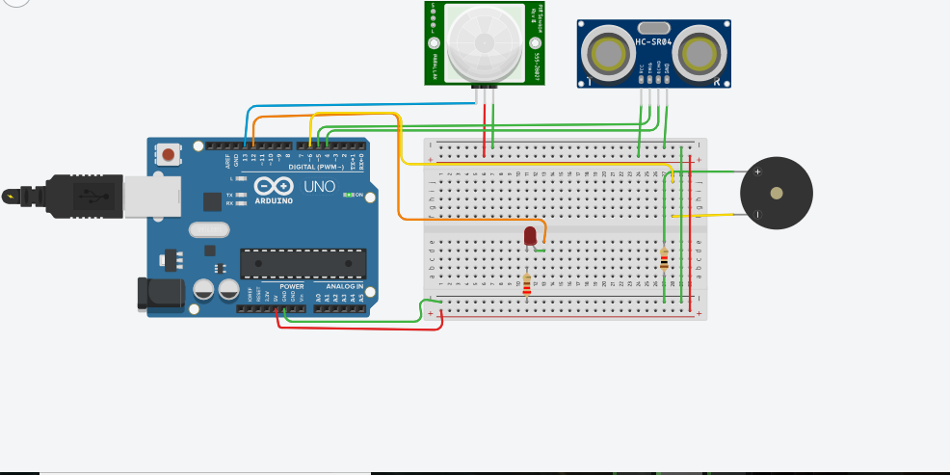

Program:

// C++ code

//

int PIR = 0;

int Distance = 0;

long readUltrasonicDistance(int triggerPin, int echoPin)

{

pinMode(triggerPin, OUTPUT); // Clear the trigger

digitalWrite(triggerPin, LOW);

delayMicroseconds(2);

// Sets the trigger pin to HIGH state for 10 microseconds

digitalWrite(triggerPin, HIGH);

delayMicroseconds(10);

digitalWrite(triggerPin, LOW);

pinMode(echoPin, INPUT);

// Reads the echo pin, and returns the sound wave travel time in microseconds

return pulseIn(echoPin, HIGH);

}

void setup()

{

pinMode(13, INPUT);

pinMode(12, OUTPUT);

pinMode(6, OUTPUT);

}

void loop()

{

PIR = digitalRead(13);

delay(10); // Wait for 10 millisecond(s)

if (PIR == HIGH) {

digitalWrite(12, HIGH);

delay(1); // Wait for 1 millisecond(s)

} else {

digitalWrite(12, LOW);

}

Distance = 0.01723 * readUltrasonicDistance(5, 4);

if (Distance <= 100) {

tone(6, 880, 125); // play tone 69 (A5 = 880 Hz)

delay(125); // Wait for 125 millisecond(s)

} else {

noTone(6);

}

}

Component:

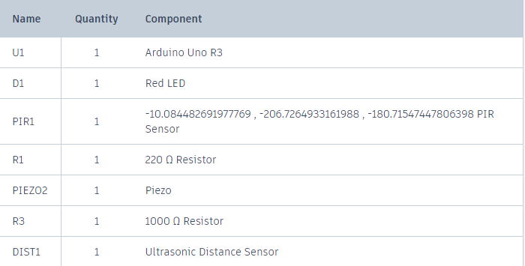

Output:

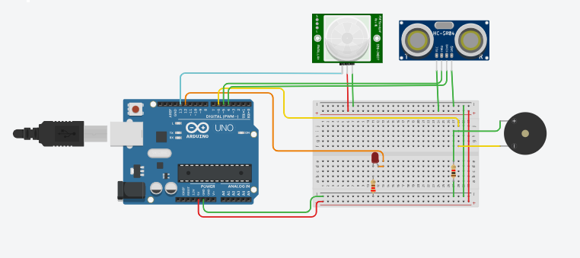

Advantages:

1. **Reduced Loss of Life:** The primary advantage of flood monitoring and early warning systems is the ability to save lives. By providing advance notice of impending floods, people have more time to evacuate to safer areas.
2. **Minimized Property Damage:** Early warnings also help reduce property damage by allowing individuals and communities to take precautionary measures such as moving belongings to higher ground or installing flood defenses.
3. **Increased Preparedness:** These systems promote community preparedness by raising awareness about flood risks and encouraging the development of evacuation plans, emergency kits, and infrastructure improvements.
4. **Quick Response:** Flood monitoring systems can provide real-time data on flood conditions, allowing emergency services to respond rapidly and efficiently.
5. **Economic Benefits:** Timely warnings can prevent significant economic losses by minimizing disruptions to businesses and agriculture, as well as reducing the need for disaster relief and recovery efforts.
6. **Environmental Protection:** Early warnings can also benefit the environment by giving authorities more time to implement measures to safeguard ecosystems and natural habitats.
7. **Improved Infrastructure Planning:** The data collected by monitoring systems can be used for better urban planning, including the construction of flood-resistant infrastructure.
8. **Public Awareness:** Flood warnings can raise awareness of flood risks and the need for responsible land use and floodplain management.

Disadvantages:

1. **False Alarms:** One of the major drawbacks is the potential for false alarms, which can lead to complacency and mistrust in the system. People may ignore warnings if they feel they are unreliable.
2. **Infrastructure Costs:** Establishing and maintaining a flood monitoring and early warning system can be expensive, including the cost of sensors, data processing, and communication infrastructure.
3. **Maintenance and Upkeep:** Continuous maintenance and periodic upgrades are required to ensure the system remains effective and accurate.
4. **Limited Coverage:** Not all areas have access to flood monitoring and early warning systems, leaving some communities vulnerable to floods.
5. **Population Density and Vulnerability:** These systems may not be as effective in densely populated or economically disadvantaged areas, where evacuation and response may be more challenging.
6. **Environmental Impact:** The installation of monitoring equipment can have some environmental impact, and there can be concerns about habitat disruption and resource consumption.
7. **Limited Lead Time:** In some cases, such as flash floods, there may be limited lead time for warnings, making it challenging to evacuate people and assets in time.
8. **Community Engagement:** Effective warning systems require active community engagement and education, which can be difficult to achieve in some areas.